University of Jordan
Department of Computer Engineering
Digital Logic Laboratory
Lab Project
Due Date (30/4/2017)

The purpose of this project is to design a 4-bit adder/subtractor. The adder/subtractor should perform signed and unsigned add and subtract operations. The block diagram of the adder/subtractor is shown in Figure 1.
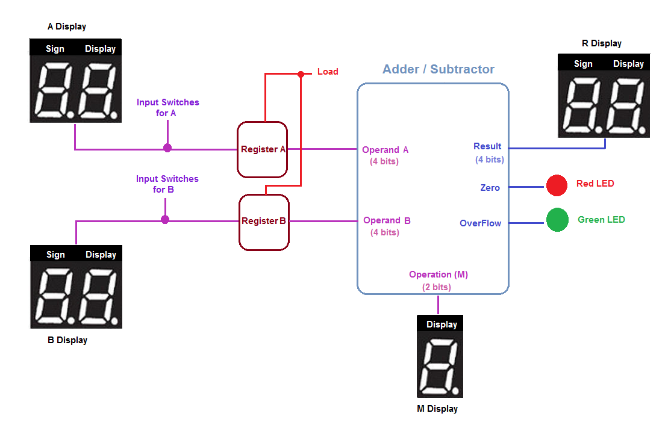
Figure 1: Addrer/Subtractor Block Diagram
- Adder/Subtractor Inputs
The adder/subtractor has two data inputs A(A₃A₂A₁A₀) and B(B₃B₂B₁B₀) and the operation M(M₁M₀). Based on the value of M the values of A and B will be added or subtracted. Table 1 shows the operation for each value of M.
M₀ | M₁ | Operation
0 | 0 | Unsigned add
0 | 1 | Unsigned subtract
1 | 0 | Signed add
1 | 1 | Signed subtract
Table 1: Adder/Subtractor operations

The data inputs to the adder/subtractor module will be read from two 4 bits registers. Register A will have the value of A. Register B will have the value of B. The values at the inputs of the registers will be controlled using the switches on the FPGA. When the Load Switch is high, the registers will be loaded with the values represented by the switches. The Load signal will used to trigger the Parallel load control signal of the registers to perform this task.
After the registers are loaded with A and B values, the adder/subtractor is supposed to perform the operation specified by M which is also controlled by two switched on the FPGA.
- Adder/Subtractor Outputs
After the adder/Subtractor module finishes execution then the result will be displayed on a 7 segment display. In addition to output of the performed operation the adder/subtractor will generate the overflow and zero outputs, each of them will be displayed on an LED. Table 2 shows the description of the overflow and the zero outputs.
Overflow | =1 The performed operation has an overflow
Overflow | =0 The performed operation does not have an overflow
Zero | =1 The result of the performed operation is 0
Zero | =0 The result of the performed operation is not Zero
Table 2: Details of the Overflow and Zero outputs
- Display of Results
To make it easier the inputs and the outputs values will be displayed on 7 segment displays. Figure 2 and Table 3 show the details of how the data is displayed on the 7 segment displays for each operation.
Sign A | Display A | Sign B | Display B | Display M | Sign R | Display R
Figure 2: Names and order of the 7-segment displays
Operands A and B
Sign | Signed Add/subtract | Displays "-" when the number is negative  OFF when the number is positive
Sign | Unsigned Add/subtract | Always OFF
Display | Unsigned Add/subtract | Display the value of the operand (Between 0-F)
Display | Signed Add/subtract | Display the absolute value of the operand.  Example:  If A = 1111 then A Display should show 1 = |-1|  If B = 0111 then B Display should show 7 = |7|
Result (R)
Sign | unsigned Add/subtract | Display "-" if A < B (borrow bit =1)  OFF if A>=B (borrow bit =0)
Sign | signed Add/subtract | Display "-" when the number is negative  OFF when the number is positive
Display | unsigned Add/subtract | No borrow: Display the value of R (Between 0-F)  Borrow: Display the 2's complement of R.
Display | signed Add/subtract | Display the absolute value of R  Example:  If R₃R₂R₁R₀ ₌ 1111 then R Display should show 1 = |-1|  If R₃R₂R₁R₀ ₌ 0111 then R Display should show 7 = |7|
Operation (M)
Display | All operations |  | Display the value of M  00 0 01 1  10 2 11 3

Table 3: Design specifications
- Submission Guidelines
- Students are allowed to work in teams of two and students from different sections can work in the same team.
- Each team should email all the project files to their lab engineer before the deadline.
  - Eng. Alaa Thaher Al.thaher@ju.edu.jo
  - Eng. Rawan Al-jamal R.aljamal@ju.edu.jo
  - Eng. Amal Quzmar A.quzmar@ju.edu.jo

- Each team should be able to show a demo of the working project to their instructor and lab engineer during their lab section.
- Students are expected to answer all the questions during the discussion.
- Cheating will not be tolerated.

- Pin Assignments

1- R Display (HEX1: Sign, HEX0: Display)
a1 | oHEX1_D[0] | PIN_AG13
b1 | oHEX1_D[1] | PIN_AE16
c1 | oHEX1_D[2] | PIN_AF16
d1 | oHEX1_D[3] | PIN_AG16
e1 | oHEX1_D[4] | PIN_AE17
f1 | oHEX1_D[5] | PIN_AF17
g1 | oHEX1_D[6] | PIN_AD17
a0 | oHEX0_D[0] | PIN_AE8
b0 | oHEX0_D[1] | PIN_AF9
c0 | oHEX0_D[2] | PIN_AH9
d0 | oHEX0_D[3] | PIN_AD10
e0 | oHEX0_D[4] | PIN_AF10
f0 | oHEX0_D[5] | PIN_AD11
g0 | oHEX0_D[6] | PIN_AD12

2- B Display (HEX5: Sign, HEX4: Display)
a5 | oHEX5_D[0] | PIN_M3
b5 | oHEX5_D[1] | PIN_L1
c5 | oHEX5_D[2] | PIN_L2
d5 | oHEX5_D[3] | PIN_L3
e5 | oHEX5_D[4] | PIN_K1
f5 | oHEX5_D[5] | PIN_K4
g5 | oHEX5_D[6] | PIN_K5
a4 | oHEX4_D[0] | PIN_P1
b4 | oHEX4_D[1] | PIN_P2
c4 | oHEX4_D[2] | PIN_P3
d4 | oHEX4_D[3] | PIN_N2
e4 | oHEX4_D[4] | PIN_N3
f4 | oHEX4_D[5] | PIN_M1
g4 | oHEX4_D[6] | PIN_M2

3- A Display (HEX7: Sign, HEX6: Display)
a7 | oHEX7_D[0] | PIN_K3
b7 | oHEX7_D[1] | PIN_J1
c7 | oHEX7_D[2] | PIN_J2
d7 | oHEX7_D[3] | PIN_H1
e7 | oHEX7_D[4] | PIN_H2
f7 | oHEX7_D[5] | PIN_H3
g7 | oHEX7_D[6] | PIN_G1
a6 | oHEX6_D[0] | PIN_H6
b6 | oHEX6_D[1] | PIN_H4
c6 | oHEX6_D[2] | PIN_H7
d6 | oHEX6_D[3] | PIN_H8
e6 | oHEX6_D[4] | PIN_G4
f6 | oHEX6_D[5] | PIN_F4
g6 | oHEX6_D[6] | PIN_E4

4- M Display (HEX3)
a3 | oHEX3_D[0] | PIN_P6
b3 | oHEX3_D[1] | PIN_P4
c3 | oHEX3_D[2] | PIN_N10
d3 | oHEX3_D[3] | PIN_N7
e3 | oHEX3_D[4] | PIN_M8
f3 | oHEX3_D[5] | PIN_M7
g3 | oHEX3_D[6] | PIN_M6

5- Overflow and Zero pins:
Overflow | oLEDG[7] | PIN_AA24
Zero | oLEDR[0] | PIN_AJ6

6- Input Switches (A and B Operands):
A0 | iSW[1] | PIN_AB26
A1 | iSW[2] | PIN_AB25
A2 | iSW[3] | PIN_AC27
A3 | iSW[4] | PIN_AC26
B0 | iSW[14] | PIN_L5
B1 | iSW[15] | PIN_L4
B2 | iSW[16] | PIN_L7
B3 | iSW[17] | PIN_L8
Load | iSW[0] | PIN_AA23
M0 | iSW[10] | PIN_W5
M1 | iSW[11] | PIN_V10
Clock |  | PIN_E16

